Breakfast  Frita Egg & Cheese / $8.50  Our Cuban frita burger with cheese, topped with an egg and served with a hefty side of our specialty string potatoes. A delicious way to start your day!  Pan con Tortilla / $8.50  Chorizo, egg & cheese omelet served on Cuban bread.  Cuban Breakfast Sandwich / $8.50  Ham, swiss & two over-easy eggs served on Cuban bread. A hearty way to start the day.  Lala’s Monte Cristo / $9.75  Ham, Swiss Cheese on Texas Toast, topped with crispy bacon and a drizzle of cayenne maple syrup & a side of chips. A hearty way to start the day.  Sides & Drinks  Sweet Plantains, White Rice, Today’s Sautéed Vegetables / $3  Black Beans & Rice / $6  Black Beans / $3.75  Bottled Tea, Soda / $2.50  Canned Soda / $1.75  Bottled Water / $1.50  Niños  Kid-sized portions / $3.95  Spaghetti, Grilled Cheese, Hot Dog | Lala’s Kitchen  in the Mountains  - Dine-In / Carry-Out  Visit us on Facebook @  Lala’s Kitchen in the Mountains  - 53B Merchant’s Walk – 706.745.0511  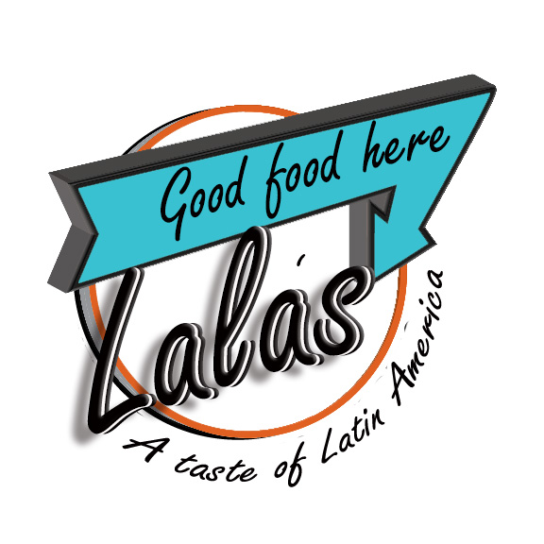  - Mon – Thur 10:30am – 8pm  Fri & Sat 10:30am – 9:30pm  Sunday Closed
Sandwiches & Bowls  Order ‘as-is’ or customize it!  Bread: Cuban, Ciabatta or Texas Toast  Cheese: Muenster, Provolone, Swiss & American  Toppings: Lettuce, Tomatoes, Onions, Pickles, Jalapeños, Green Olives or Black Olives / Sauces: Gisela’s Special Mojo Sauce, House Mustard, Special Garlic Sauce  The Colombian Dog / $8.75  Our all-beef hotdog with Mayo, Ketchup, Mustard, Chunks of fresh Pineapple, slaw and mozzarella cheese, topped with our specialty shoe-string potatoes.  The Venezuelan / $9.75  Shredded beef, a generous portion of mozzarella and topped with our special garlic sauce.  Lissy’s Cuban / $9.95  Generous portions of Ham, Swiss & Roasted Pork, with our very own house mustard, served on authentic Cuban bread and served with pickles. Turkey version available.  Chicken Guacamole Special / $9.75  Just like the name says, our Chicken Guacamole is something special! Fresh grilled chicken breast topped with a generous portion of guacamole.  Pan con Lechon / $9.50  Our slow-roasted pulled pork, topped with our own mojo - made with onions, garlic and our special blend of spices -and served on fresh Cuban bread.  The Ecuadorian / $9.75  Hot off the grill, our slow roasted pork & Lala’s pickled onions with a splash of hot sauce is a sandwich to remember.  The Key West / $9  Tuna Salad Sandwich, fresh lettuce & tomato on our freshly baked Ciabatta bread.  Puerto Rican Club / $10.95  Generous portions of Ham, Salami, Turkey, Swiss & American Cheeses, Mayo, Mustard, Spicy Sauce, Lettuce & Tomato. Served with Chips  Reuben Rodriguez / $10.95  Corned Beef aged to perfection topped with Pineapple Slaw with Chipotle Mayo on Ciabatta Bread. Served with Chips.  The ‘Impossible’ Caribbean Burger (Vegan) / $10.95  6oz patty with chimichurri sauce made with garlic, cilantro & olive oil.  The Gaucho Burger / $9.50  8oz of fresh beef that’s topped with Provolone Cheese & a house-made chimi-churry sauce. | Entrees  Meatballs Barcelona / $14.95  Slow-cooked ground beef meatballs, with our special red sauce.  Shrimp Creole / $18.95  Six Jumbo Shrimp, rice and beans with our mildly spiced red sauce.  Ropa Vieja / $14.95  Known all over the Caribbean, Ropa Vieja is made with shredded beef, tomatoes, onions, roasted red peppers, garlic, cumin, cilantro, olive oil and a dash of vinegar.  Pollo con Zetas en Crèma Blanca / $14.95  Pulled chicken with mushrooms, cream-sauce served over yellow rice and served with plantains.  Meat Pastitsio / $13.95  Traditionally a Greek dish, our version of Pastitsio has a Latin American twist. You’ll love our version of Lasagna and will be left wanting more!  Soups, Salad & Bowls  Garbanzo / $6.50  Chorizo, ham hocks and a blend of spices make for a hearty soup that is synonymous with Spain.  Johnny’s French Onion / $6.50  You’ll think you’re in Paris when you try our French onion soup!  Split Pea / $6.50  Comfort food at its best!  Black Beans & Rice / $6  Simple & filling  Caesar Salad / $7.95  Traditional Caesar Salad w/Chicken / $10.50  Bowls-to-go! / $7.95  Pork, Chicken or Beef over a bed of rice & beans.  Desserts  Tres Leche’s / $5.50  Also known as ‘Milk Cake’, our version of Tres Leche’s is made with three layers and features four types of milk: Whole, Condensed, Evaporated & Heavy Cream.  Rum Tres Leche’s / $5.75  Just like our regular Tres Leche’s, but with lots of Rum!  Passion Fruit Flan / $5  A tropical twist to a traditional dish, our Passion Fruit Flan will transport you to the Island of Cuba!  Bread Pudding with Bourbon Sauce / $6.50  You know you want to try it!

