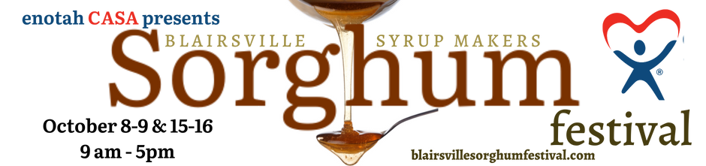

Sorghum Festival Parade Entry Form
OCTOBER 8, 2022
Theme: Appalachian Heritage

Please complete entire form (both sides) for each entry

Name of Organization/Entry ____________________________________________________________
Contact Person(s) ____________________________________________________________________
Contact Address ____________________________________________________________________
City ______________________________________State _____________Zip Code ________________
Daytime Phone # (_____)_____________________ Cell Phone # (_____)_____________________
E-Mail Address _______________________________________________________________________
Parade Day contact Phone # (in case of cancellation or delay) (______)________________________
Check all that apply: [for entry descriptions, see attached]
__ Float Length of Float or Trailer: __________
__ Community Float
__ Motorized Vehicle
__ Motorized Vehicle Group
__ Instrumental Marching Group
__ Pedestrian Walking Group
__ Check one that best describes your entry
__ Business
__ Non-business/civic and community (i.e., scouts, fire company, ambulance, LEMSA, EMTs, etc.)
__ Elected Official (not currently running for office)
__ Political Office Candidate
__ Media (TV, Radio, Print)
__ School Group or Club
__ Other________________________________
- Please note horses are not an allowed entry unless your entity has someone to follow and clean behind the horse.
REQUIRED Information (please estimate the following, where necessary):

Music Yes___ No___ If yes, Live____ Recorded ____

____Total # of people walking: # of Adults (over 18)_______ # of Children ________
____ Total # of people riding: # of Adults (over 18)_______ # of Children ________
____ # of vehicles Size of vehicles: Length:____________

Type of vehicles (make/model/yr): ___________________________________________________

Any special needs considerations? ______________________________________________________

If necessary, please contact the parade headquarters 5 days prior to parade with changes.

□ Sorry, we are unable to participate this year.
All entrants must read and complete the reverse side of this form
Did you previously participate in the parade? ______
PARADE ENTRY FORM (continued)
Please note the following:
1) Any individuals who operate a truck, car, tractor or any other type of vehicle in the parade must possess a valid driver’s license.
2) The Parade Committee reserves the right to limit the number/type of vehicles and other entries in the parade.
3) Entries received after October 3, 2022 will be accepted only upon approval from the Parade Organizing Chair.
4) Parade entries should check-in between 9am-9:30am at the big field/Old Rec Gym. Each entry will receive their assigned spot in the line-up.
5) Please do not park your personal vehicles along the parade route.
6) The start of the parade will begin at 10am at the big field of the Old Rec Gym and will proceed through the town. The parade will end at the big field of the Old Rec gym, as well. At the end of the parade, you will disperse.
7) All participants are expected to abide by general behavior guidelines.
8) Union County Government, Enotah CASA, Grandaddy Mimm’s Distilling Co., and the parade committee members do not endorse the views, representations, and behaviors of parade participants.
9) Please use caution when throwing candy or other objects along the parade route. Please throw into the crowd and not in the road along the parade route. At no time do we want those viewing the parade to enter the parade route on the road.

The organization named on this application irrevocably grant the Blairsville Sorghum Festival, Enotah CASA, Inc. and Grandaddy Mimm’s Distilling Co. the exclusive right to use in any media our name, likeness, photos, or reproduction of our performance for any purpose including promotion, advertising or otherwise.Furthermore, I/we hereby understand and agree to accept the risk of bodily injury and/or property damage which I/we may incur or
cause a third party to incur as a result of my/our participation in the Parade. With this understanding, I/we further agree to indemnify, defend and save harmless the Blairsville Sorghum Festival Parade Organizers and Enotah CASA members, respective officers, agents, sponsors and employees from and against any and all claims, losses, injuries suits and judgments arising from, or in conjunction with/my successors, assigns, heirs, executors and administrators, and any other persons or entities who/which may have a claim based on my/our personal injuries and/or property damage. I/we further understand and agree that this save harmless and indemnification shall apply to and all facilities that above named organizers may own or operate. I/we understand and agree that the Parade may be televised and all participants in the parade relinquish all present and future television, video and photographic rights by virtue of their appearance. Furthermore, I/we have read and agree to abide by the Parade guidelines and rules, as shown in
the pages provided and those to be presented with the participant’s information package for my entry. This application must be signed.
ALL entries are subject to approval by the parade organizers. Your signature is required as an indication that you have read and
understand the information presented on this form and that your entity agrees to comply with all rules established
.
_____________________________________________ Date _____________________
(Signature)
_____________________________________________
(Please print name of signature person above)

Please complete and return this entry form by October 3, 2022

email to: megan@grandaddymimms.com

OR

Mail to:
Sorghum Festival Parade
Attn: Megan Kimsey
P.O. Box 2419 Blairsville, GA 30514

Questions? Contact Megan at (706) 781-1829 ext. 001
megan@grandaddymimms.com

